Bridge Design Pattern
When we have interface hierarchies in both interfaces as well as implementations, then the BRIDGE design pattern is used to decouple the interfaces from implementation and hiding the implementation details from the client programs.
According to the GoF bridge design pattern is: Decouple an abstraction from its implementation so that the two can vary independently.
In the Bridge Pattern, we separate an abstraction and its implementation and develop separate inheritance structures for both the abstraction and the implementer. The abstraction is an interface or an abstract class, and likewise the implementer is an interface or an abstract class. The abstraction contains a reference to the implementer. Children of the abstraction are referred to as refined abstractions, and children of the implementer are concrete implementers. Since we can change the reference to the implementer in the abstraction, we are able to change the abstraction’s implementer at run-time. However, changes to the implementer do not affect client code.
The Bridge Pattern’s intent is to put the abstraction and implementation into two different class hierarchies so that both can be extend independently.
Adapter Pattern vs Bridge Pattern
The Adapter Design Pattern helps it two incompatible classes to work together. But the Bridge Design Pattern decouples the abstraction and implementation by creating two different hierarchies.
Example
For example, let’s observe the code below in order to understand the Bridge Design Pattern. Before that, just look at the diagram below to make everything clear.
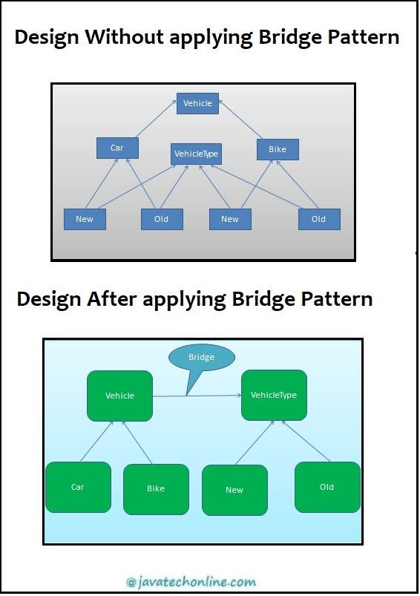
Vehicle.java
/**
* abstraction in Bridge pattern
* */
public abstract class Vehicle {
protected VehicleType type1;
protected VehicleType type2;

public Vehicle(VehicleType type1, VehicleType type2) {
this.type1 = type1;
this.type2 = type2;
}

abstract public void purchase();
}
VehicleType.java
/**
* Implementor for Bridge pattern
* */
public interface VehicleType {

abstract public void book();
}
Car.java
/**
* Refine abstraction 1 in Bridge pattern
*/
public class Car extends Vehicle {

public Car(VehicleType type1, VehicleType type2) {
super(type1, type2);
}

@Override
public void purchase() {
System.out.print("Car");
type1.book();
type2.book();
}
}
Bike.java
/**
* Refine abstraction 2 in Bridge pattern
*/
public class Bike extends Vehicle {

public Bike(VehicleType type1, VehicleType type2) {
super(type1, type2);
}

@Override
public void purchase() {
System.out.print("Bike");
type1.book();
type2.book();
}
}
NewVehicle.java
/**
* Concrete implementation 1 for Bridge pattern
* */
public class NewVehicle implements VehicleType {

@Override
public void book() {
System.out.print(" : New Vehicle");
}
}
OldVehicle.java
/**
* Concrete implementation 2 for Bridge pattern
* */
public class OldVehicle implements VehicleType {

@Override
public void book() {
System.out.println(" : Old Vehicle");
}
}
BridgePatternTest.java
public class BridgePatternTest {

public static void main(String[] args) {

Vehicle vehicle1= new Car(new NewVehicle(),new OldVehicle());
vehicle1.purchase();

Bike vehicle2 = new Bike(new NewVehicle(),new OldVehicle());
vehicle2.purchase();
}
}
Output
Car : New Vehicle : Old Vehicle
Bike : New Vehicle : Old Vehicle
When to Use and other points
- Should be used when we have a need to switch implementation at runtime.
- The client should not be impacted if there is a modification in implementation of abstraction.
- Best used when you have multiple implementations.
- Creates two different hierarchies. One for abstraction and another for implementation.
- Avoids permanent binding by removing the dependency between abstraction and implementation.
- We create a bridge that coordinates between abstraction and implementation.
- Abstraction and implementation can be extended separately.
Usage in JDK
- AWT (It provides an abstraction layer which maps onto the native OS the windowing support.)
- JDBC
Here, we have completed the fifth design pattern of our article ‘Structural Design Patterns In Java’.

